**Contents:**

**1.** **Introduction:** 2

**2.** **Origins and Early Development:** 2

**a.** **Pre-Christian Influences:** 2

**b.** **Martyr Remembrances in Early Christianity:** 3

**3.** **Spread Through Europe:** 3

**4.** **All Saints' Day and the Protestant Reformation:** 3

**5.** **Modern Observance:** 3

**6.** **Conclusion:** 3

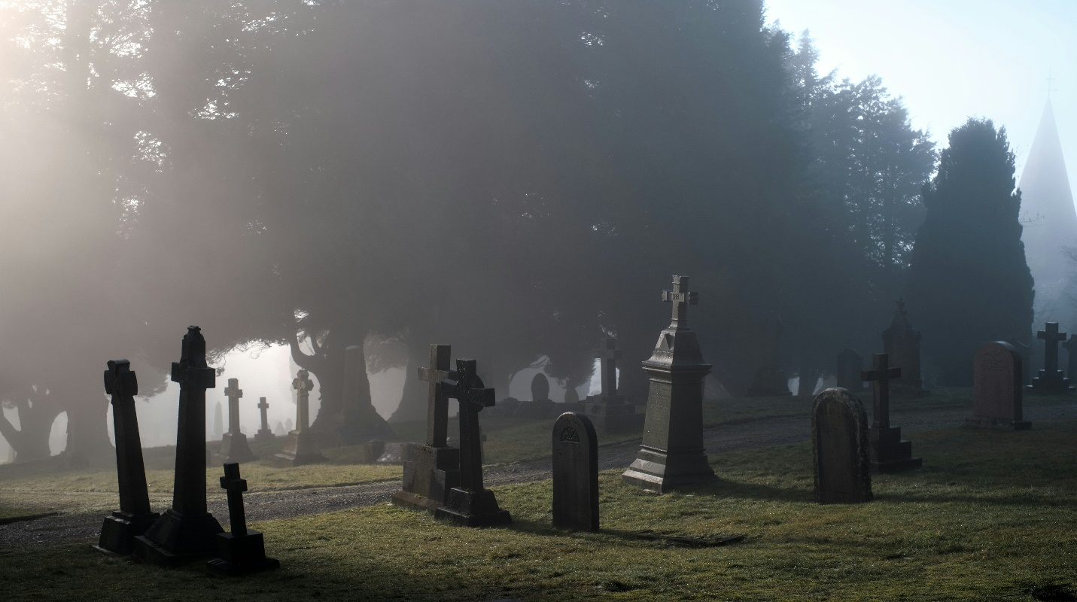

**History Of All Saint’s Day**

# **Introduction:**

All Saints' Day, also known as the Feast of All Saints, is a Christian solemnity celebrated annually on November 1st. It honors all the saints—known and unknown—who have attained heaven. This day is especially significant in the Roman Catholic Church, the Eastern Orthodox Church, Anglican Communion, and various Protestant traditions. It serves as a celebration of the communion of saints and a reminder of the spiritual connection between the living and the dead in Christian theology.

# **Origins and Early Development:**

## **Pre-Christian Influences:**

The roots of All Saints’ Day can be traced back to early Christian practices and possibly even earlier pagan traditions. Some scholars suggest that the date and themes of All Saints’ Day were influenced by Samhain, a Celtic festival marking the end of the harvest season and a time when the veil between the living and dead was believed to be thin.

## **Martyr Remembrances in Early Christianity:**

In the early centuries of Christianity, specific days were dedicated to remembering individual martyrs. As persecution of Christians increased during the Roman Empire, the number of martyrs grew rapidly—so much so that there were not enough days in the calendar to honor them all.

# **Spread Through Europe:**

As Christianity spread across Europe, the observance of All Saints’ Day became widespread. The date of November 1 may have been deliberately chosen to replace pagan festivals, particularly Samhain in Celtic regions like Ireland and Britain.

# **All Saints' Day and the Protestant Reformation:**

During the Protestant Reformation in the 16th century, many Protestant denominations rejected the veneration of saints in the Catholic sense. However, some, such as Anglicans and Lutherans, retained a version of All Saints' Day to honor holy lives and Christian examples.

# **Modern Observance:**

Today, All Saints' Day is celebrated in diverse ways across Christian denominations:

* Roman Catholic Church:

A Holy Day of Obligation (where attendance at Mass is required). Services include readings, prayers, and hymns focused on the saints’ faithfulness and intercession.

* Eastern Orthodox Church:

Celebrates All Saints' Day on the first Sunday after Pentecost. Focuses on the unity of the Church across time and eternity.

# **Conclusion:**

All Saints’ Day stands as a powerful celebration of holiness, memory, and community within the Christian tradition. From its early roots in honoring martyrs to its current role in connecting the living and the dead, the day continues to inspire Christians around the world to reflect on the lives of the saints and strive to live in faith, love, and service.